**DataSpark: Illuminating Insights for Global Electronics**

**1. Executive Summary**

**Overview:**  
The report provides a comprehensive analysis of Global Electronics' data, highlighting customer behaviors, sales trends, product performance, and store operations.

**Key Objectives:**  
The primary goals are to enhance customer satisfaction, optimize inventory, and drive business growth through data-driven insights.

**Major Findings:**

* **Customer Insights:** Identification of key customer segments, purchasing patterns, and retention rates.
* **Product Insights:** Recognition of top-performing products and categories.
* **Store Insights:** Evaluation of store performance and geographical sales analysis.
* **Currency Impact:** Analysis of how currency exchange rates affect sales and profitability.

**Main Recommendations:**

* Tailored marketing strategies for different customer segments.
* Inventory management optimization based on sales data.
* Improved pricing strategies considering currency fluctuations.

**2. Introduction**

**Purpose and Scope:**  
This analysis seeks to uncover actionable insights from the company’s data to inform strategic decisions.

**Datasets and Methodology:**  
Datasets include customer demographics, sales transactions, product details, store information, and exchange rates. The analysis follows EDA principles for data cleaning, exploration, and visualization.

**3. Data Overview**

**Datasets Description:**

* **Customers:** Demographic and location data.
* **Sales:** Transactional data including order and delivery details.
* **Products:** Product attributes such as cost, price, and category.
* **Stores:** Store locations, sizes, and operational dates.
* **Exchange Rates:** Historical exchange rate data.

**Data Cleaning and Preparation:**  
Data was cleaned by addressing missing values, correcting data types, treating outliers, and standardizing variables.

**Assumptions and Limitations:**  
The analysis assumes data completeness and accuracy but acknowledges potential biases due to missing or incorrect data entries.

Datasets Overview:

|  |  |  |
| --- | --- | --- |
| **Table** | **Field** | **Description** |
| Sales | Order Number | Unique ID for each order |
| Sales | Line Item | Identifies individual products purchased as part of an order |
| Sales | Order Date | Date the order was placed |
| Sales | Delivery Date | Date the order was delivered |
| Sales | CustomerKey | Unique key identifying which customer placed the order |
| Sales | StoreKey | Unique key identifying which store processed the order |
| Sales | ProductKey | Unique key identifying which product was purchased |
| Sales | Quantity | Number of items purchased |
| Sales | Currency Code | Currency used to process the order |
| Customers | CustomerKey | Primary key to identify customers |
| Customers | Gender | Customer gender |
| Customers | Name | Customer full name |
| Customers | City | Customer city |
| Customers | State Code | Customer state (abbreviated) |
| Customers | State | Customer state (full) |
| Customers | Zip Code | Customer zip code |
| Customers | Country | Customer country |
| Customers | Continent | Customer continent |
| Customers | Birthday | Customer date of birth |
| Products | ProductKey | Primary key to identify products |
| Products | Product Name | Product name |
| Products | Brand | Product brand |
| Products | Color | Product color |
| Products | Unit Cost USD | Cost to produce the product in USD |
| Products | Unit Price USD | Product list price in USD |
| Products | SubcategoryKey | Key to identify product subcategories |
| Products | Subcategory | Product subcategory name |
| Products | CategoryKey | Key to identify product categories |
| Products | Category | Product category name |
| Stores | StoreKey | Primary key to identify stores |
| Stores | Country | Store country |
| Stores | State | Store state |
| Stores | Square Meters | Store footprint in square meters |
| Stores | Open Date | Store open date |
| Exchange Rates | Date | Date |
| Exchange Rates | Currency | Currency code |
| Exchange Rates | Exchange | Exchange rate compared to USD |

**4. Analysis and Insights**

**Customer Analysis**

* **Demographic Distribution:** Analysis of customer demographics such as age, gender, and location.
* **Purchase Patterns:** Insights into average order value, purchase frequency, and preferred products.
* **Customer Segmentation:** Segmentation based on demographic and purchasing behaviors to identify key customer groups.

**Sales Analysis**

* **Overall Sales Performance:** Analysis of sales trends over time to identify seasonal patterns.
* **Sales by Product:** Evaluation of top-performing products and their contribution to revenue.
* **Sales by Store:** Assessment of store performance based on sales data.
* **Sales by Currency:** Analysis of sales impact due to currency fluctuations.

**Product Analysis**

* **Product Popularity:** Identification of most and least popular products.
* **Profitability Analysis:** Profit margin calculation by comparing unit cost and price.
* **Category Analysis:** Sales performance analysis across product categories.

**Store Analysis**

* **Store Performance:** Evaluation of store sales and operational efficiency.
* **Geographical Analysis:** Analysis of sales distribution across different regions.

**5. Actionable Recommendations**

**Marketing Strategies:**  
Develop targeted campaigns based on customer segmentation. Focus on key marketing areas for better engagement.

**Inventory Management:**  
Optimize stock levels by analyzing sales trends and forecasts. Implement strategies to manage slow-moving products.

**Sales Forecasting:**  
Utilize historical sales data for trend analysis and promotional planning.

**Product Development:**  
Focus on product development areas based on market trends. Implement bundling strategies to boost sales.

**Store Operations:**  
Adopt best practices from top-performing stores. Implement operational improvements to enhance efficiency.

**International Pricing:**  
Adjust pricing strategies based on currency impacts to maximize profits.

**Customer Retention:**  
Develop loyalty programs and retention strategies targeting specific customer segments.

**Cross-Selling and Upselling:**  
Design campaigns based on product affinities and implement bundling offers to increase sales.

**6. Future Enhancement Strategies**

**Data Analytics and AI Integration:**  
Incorporate predictive analytics and AI for better decision-making and personalized marketing.

**Digital Transformation:**  
Enhance the online shopping experience and integrate omnichannel strategies for a seamless customer experience.

**Customer Experience Enhancement:**  
Improve personalized interactions and customer service capabilities.

**Sustainable Practices:**  
Implement eco-friendly operations and sustainable product sourcing.

**Strategic Partnerships:**  
Explore partnerships for innovation, logistics, and improved customer satisfaction.

**7. Areas for Improvement**

* **Data Quality:** Enhance data collection and storage processes.
* **Technology Upgrades:** Invest in advanced tools for better analysis.
* **Employee Training:** Provide training on new tools and technologies.
* **Customer Feedback:** Implement systems to collect and analyze customer feedback.

**8. Conclusion**

The report has provided insights into customer behaviors, product performance, and store operations, offering actionable recommendations to enhance customer satisfaction, optimize inventory, and drive business growth. Implementing these strategies will ensure Global Electronics remains competitive in the evolving market.

**9. Results**

**Customer analysis-Sum of customer count by city:**

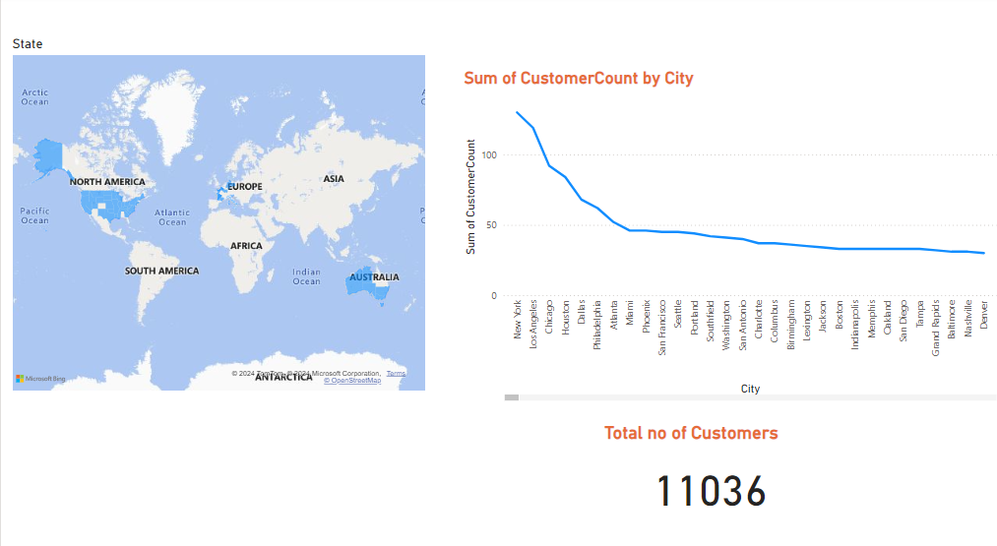

**2.** **product analysis- Revenue Generate**

**3. Sales Analysis - Totalsales by category and month**

**4. Product analysis- Sum of LTV by customerkey**

**5. customer analysis- customer count by Gender**

**6. Sales analysis- total sales by store key**

**7. Stores Analysis- First order date by storekey**

**8. Sales Analysis - Totalsales by category and month**

**9. Business Analysis - Customer key by LTV**

**10. References**

* Data from Global Electronics like Customers, Sales, Products, Stores and Exchange Rates.
* Python, Power BI, and SQL tools used for analysis and visualization.